“The Rise of Social Intelligence and the Measurement of Mental Deficiency”

Or

“From Threat to Promise: The Rise of Social Intelligence in the Measurement of Mental Deficiency”

Adrianna Bagnall-Munson

Department of Sociology, Columbia University

[a.bagnall@columbia.edu](mailto:a.bagnall@columbia.edu)

January 2018

**Abstract**

The allocation of services and supports to people with disabilities is a bureaucratic process of assessing a person's ability and issuing a legal determination of their disability status. A diagnosis of intellectual and developmental disability is reserved for individuals who display deficits in both their mental intelligence and social function. These deficits are measured using standardized diagnostic instruments: the intelligence test and tests of adaptive function. The purpose of diagnostic tests like these is to provide an objective determination that can be communicated outside the medical world. Undoubtedly, their use also has social implications for our understanding of disability and difference. To better understand the role that diagnostic instruments play in shaping the social lives of people affected by disability requires an analysis of the process of creating them. This paper investigates the development of the Intelligence Test and the Vineland Scale of Social Maturity from 1900-1990. The pursuit of quantitative measures for Mental Deficiency shaped our understanding of the disability in four ways. First, we saw a shift from subjective to objective assessment of disability status. Second, the use of the Intelligence Test and the Vineland Scale as complementary instruments resulted in an expansion of the content of diagnosis. The use of these tools also transformed our assessment of the similarity between people with mental deficiency and the normal population. Finally, each test advocated specific forms of treatment that differ in their emphasis on inclusion in the community.

“The Rise of Social Intelligence: Complementary Indicators in the Measurement of Mental Deficiency”

Adrianna Bagnall-Munson

**Introduction**

Stories of adults with Intellectual and Developmental Disabilities (IDD) are many in today’s lexicon. Alongside television portrayals of young adults with disabilities “making it” and finding their way in the world [1], we also see news stories about the difficulties these adults face in securing adequate supports they need to live in the world[2]. As our societal goal has become including people with IDD in everyday life, we have been confronted by their desires for love, independence, employment, and higher education; in short, their desire to participate in the world “like the rest of us.” These forms of inclusion are not without their difficulties. Rather, this inclusion requires any number of supportive relationships, technologies, and arrangements like supported employment, legal guardianships, government entitlements, and independent living.

The process of assigning these supports and services is a bureaucratic one dependent on our ability to diagnose disability. Adults with IDD are assigned benefits (income, housing, food stamps, etc.) and services (continued education, therapy, help at home, etc.) based on eligibility criteria which claims to measure their capacity for independent living, employment, self-care, and independent decision making (Certo et al. 2008). While programs may have eligibility criteria that vary slightly, all will likely require that the individual present evidence of having a documented developmental disability.

Two major medical groups have issued diagnostic criteria for Developmental/Intellectual Disability today, the American Association on Intellectual and Developmental Disabilities and the American Psychological Association. The American Association on Intellectual and Developmental Disabilities (AAIDD) is the first professional group organized for the care and research of intellectual disability. Formed in 1876 by Edouard Seguin, a pioneer in the treatment of the Mentally Deficient in the United States, as the Association of Medical Officers of American Institutions for Idiotic and Feebleminded Persons[3], the AAIDD remains the prominent organization concerned with intellectual and developmental disabilities. They maintain three journals, the *American Journal on Intellectual and Developmental Disabilities*[4], *Intellectual and Developmental Disabilities*, and *Inclusion*. The AAIDD has maintained and revised a definition of Intellectual and Developmental Disability (IDD) since 1921. Currently there are three diagnostic criteria:

1. Limitations in intellectual functioning, generally taken to mean an IQ below 70.
2. Limitations in adaptive behavior (also called adaptive functioning) as measured by standardized tests. There are three types of skills in adaptive behavior:
   1. Conceptual skills: language, literacy, mathematics, self-direction
   2. Social skills: interpersonal skills
   3. Practical skills: activities of daily living like self-care, travel, healthcare, daily routine, safety, use of money and the telephone
3. Onset of the disability before age 18

These diagnostic criteria are also consistent with the American Psychiatric Association’s criteria for IDD in the DSM-5 which differs only in terminology.

The use of intellectual and adaptive functioning as indicators of IDD are also codified law. The *Developmental Disabilities Assistance and Bill of Rights Act of 2000*, Section 102 defines developmental disability as

a severe, chronic disability of an individual that is attributable to mental or physical impairment or a combination of mental and physical impairments; is manifested before the individual attains age 22; is likely to continue indefinitely; results in substantial functional limitations in 3 or more of the following areas of major life activity

1. Self-care
2. Receptive and expressive language
3. Learning
4. Mobility
5. Self-direction
6. Capacity for independent living
7. Economic self-sufficiency; and

reflects the individual’s need for a combination and sequence of special, interdisciplinary, or generic services, individualized supports, or other forms of assistance that are of lifelong or extended duration and are individually planned and coordinated.”

In short, medical and legal definitions of developmental disability require documented impairment in mental and social functioning that occurs before the individual reaches the age of maturity (legally defined as age 22). Generally, mental function is measured by an intelligence test and social function is measured by tests for adaptive behavior (sometimes referred to as the activities of daily living). While these assessments are, on one level, tools for allocating resources, they also reflect deeper social assumptions about disability and difference.

In the social science literature, the use of the intelligence test to measure mental disability has been well documented and at times has been criticized for its limitations and biases (Carson 2007; Rothman 1980; Trent 1994). Tests for adaptive function have not been scrutinized to the same degree, leaving our understanding of the social implications of diagnosing IDD incomplete. In medical and legal diagnoses for IDD, mental and social function are given near equal weight; meaning that someone with an IQ below 70 who maintains a full-time job, is able to keep themselves safe and provides for their own daily needs will not be considered disabled or entitled to supports and services. The same is true for someone of “normal intelligence” whose home is in disrepair, who cannot keep a job, and who does not care for their own healthcare needs. In short, mental and social function are complementary indicators for the diagnosis of IDD.

This is a paper about the social consequences of measuring disability. When we measure IDD with tests for intelligence and adaptive behavior, we make latent functions of a person’s body visible and their behavior in the world comprehensible across multiple domains: law, the family, education, medicine, ethics. But measurement is not a neutral act. While measuring disability allows us to efficiently allocate money and resources to mitigate and accommodate for difference, it also draws boundaries around services and supports, limiting them to those who are “deserving” or most “in need.” In measuring disability, we also draw boundaries around social identity: who is eligible for work; what is required of a citizen; who is an “adult”; what behaviors are required for someone to be considered “normal”; how do we allocate civil and social rights? Our treatment of people with disabilities depends on who we consider them to be, therefore we should understand more fully our methods for defining and diagnosing them.

This paper will describe the development of diagnostic tools for measuring Mental Deficiency (what is today called Intellectual and Developmental Disability) and highlight its relevance to the social and political project of defining disability and assigning “appropriate” services. I identify three major phases in the measurement of Mental Deficiency, which differed in their method, content, and overall focus. The first phase was marked by the subjective observation of individuals and a comparison of their mental and social function to the life stage of children. The second phase was marked by the introduction of the intelligence test to the United States by Henry Goddard. This was important for shifting attention from subjective to objective assessment of a person’s mental capacity. Finally, I turn to the introduction of a test for adaptive behavior, the Vineland Social Maturity Scale (VSMS). The VSMS also emphasized objective assessment but expanded the content of the diagnosis to include an individual’s habitual performance in the world.

I will show that the development of these assessment tools resulted in four major transitions in our understanding of people with Mental Deficiency[5].

1. The introduction of assessment tools for mental and social function was a shift from subjective to objective measurement of mental deficiency. While this shift correlated with a broader process of quantification that occurred in other areas in the US in the twentieth century (Porter 1995; Power 1997; Ranson 2003), it is also indicative of a belief that the measurement of mental deficiency could be standardized and communicate with a number rather than sustained description.
2. In clarifying the diagnosis and identifying specific aspects of the disorder to measure, the use of both the intelligence test and the VSMS also expanded the content of diagnosis. While early efforts to diagnose MD relied on similarity to childhood as a benchmark, the use of the intelligence test and the VSMS as complementary diagnostic tools measured both latent capacity for mental functioning and an individual’s habitual performance in the world.
3. The use of assessment tools also brought about a changing understanding of the relationship of the mentally deficient to “normals.” Prior to the use of the intelligence test, the mentally deficient were viewed as categorically different from “normals.” In contrast, the intelligence test measured mental deficiency as a degree of difference from normal mental intelligence. The mentally deficient and “normals” were distinguished from each other by their location on either side of a threshold that marked the boundary between normal and deficient intelligence on a continuum.
4. Finally, each method of diagnosis brought with it a different way of understanding the treatment of the mentally deficient. Early efforts to measure MD were aimed at finding a cure. Absent a cure, the solution to caring for the MD was to segregate them from society in institutions. The intelligence test, claiming to measure latent mental capacity, characterized MD as a deficiency that was inherent to the individual’s body. Thus, cure was impossible and people with MD were provided therapeutic environments that matched their capacity to engage the community. In contrast, the Vineland scale measured habitual performance in the world—eating, cooking, carrying on conversations, performing manual labor—and emphasized that performance of these skills could be improved through training. This resulted in a more open stance toward the participation of the MD in the world and introduced new expectations that, like the normal population, they would grow and learn through training and self-regulation.

**Literature Review**

*Measurement*

Quantification, the production and consumption of numbers, occurs on many levels in society—from the facilitation of individual work like the calculation of risk (Heimer 1985) or the maintenance of navigation systems to larger social projects like the creation of a census (Hein 2004) and the use of vital statistics and public opinion in public planning (Cline Cohen 1982; Herbst 1993; Scott 1998). Through the work of quantification, individual experience is transformed into categories or characteristics of a population. For example, crime and poverty statistics (Katz 1986), indicators for health (Rusnock 2002) and intelligence levels (Carson 2007) communicate rates of social disorder or illness, and encourage the comparison of members of a society. This distillation of information makes visible “objects or characteristics that may have formerly been invisible… [permitting] scrutiny of complex or disparate phenomena in ways that enable judgement” (Espeland and Stevens 2008:415).

Quantification simplifies and distills information into a single entity, usually a number, that can be easily compared over time and across units (Espeland and Sauder 2012; Espeland and Stevens 2008). By their very nature, these numbers exclude information, focusing our attention and encouraging close scrutiny of even small differences (Espeland and Sauder 2012:92). This work is involved in many of our basic social behaviors and is a decisively social action that names objects, performs tasks, and produces effects in society.

Numbers offer a special kind of accountability for government and other social systems, one which is formalized and that seems straight forward interpret (Cline Cohen 1982; Miller and Rose 1990; Scott 1998). They make local knowledge—which “seems cumbersome, contingent, and personal”—portable and easy to communicate. Because of its utility, there has been an increased demand for quantitative accountability over the past few decades (Espeland and Vannebo 2007). Many researchers attribute this rise to neoliberal strategies of securing trust (Ranson 2003) which rely on standardized knowledge (Porter 1995) and ritualized monitoring systems (Power 1997). These facilitate “governing at a distance” (Miller and Rose 1990) by making objects “knowable” through numerical abstraction rather than prolonged personal observation.

The process of abstracting information through quantification obscures the biases, assumptions, and uncertainties involved in the production of numbers. This makes numbers appear more certain and robust (Anderson and Fienberg 1999; Desrosières 1998) and concentrates authority to entities that have access to and control over numbers.

Attempts to describe the social world through quantification affect both “experts” and the people being measured. Because of their portability across distance and discipline numbers link users with shared investments (Latour 1987) and focus or shift authority (Espeland and Vannebo 2007). Numbers have perhaps an even greater effect on the entities being measured. Numbers can create or reproduce social boundaries (Igo 2007; Lamont and Molnár 2002) and play a significant role in constructing the categories we use to think about humans, a process Hacking (1999) calls “making up people.” Through the process of describing the population, numbers also have the power to shape the behavior of individuals and institutions by defining what is normal or appropriate, and by identifying which groups of people should be subject to intervention by experts (Espeland and Stevens 2008:414). Depending on the social consequences of indicators, they also shape behavior by introducing competition and forcing actors to conform to the behavior of their fellow actors (Espeland and Sauder 2012). With these effects in mind, we can see that quantification is a political act that intervenes in the social world by causing people to think and act differently. Through numbers experts insert themselves into social problems, asserting authority to measure, sort and govern the objects of measurement.

*Measurement and Disability*

A crucial transformation that numbers have brought to the lives of people with disabilities is their power to “govern” and shape disciplinary practices. This is especially the case when statistical norms are interpreted as “moral norms” or indicators of health (Foucault 1975, 2003). The political move to give people with disabilities a morally “normal” life in the community evokes Foucault’s “techniques of normalization” whereby the abnormal behaviors of individuals are transformed so that they conform to idealized norms of conduct through training, social control, and ultimately self-discipline (Foucault 1975). Methods of measuring disability status tend to identify deficits in “typical practices” associated with autonomy or health. When these deficits are taken as markers of disability, the practices of everyday life become a site of “life work” that is reminiscent of Foucault’s self-government (Levinson 2010; Tremain 2005). Even in the context of independent living, the oft cited marker of societal progress in care for people with IDD, everyday life is transformed into a struggle for power as support workers enter the home in order to elicit self-regulation from the recipients of care (Drinkwater 2015). This tension between intervention and autonomy has been attributed to the dual identity of people with IDD as autonomous citizens and “eternal children” (A. Bagnall and Eyal 2016; Bannerman et al. 1990). In what follows I will assess the historical development of the diagnosis of IDD and explore the ways in which the diagnosis itself has contributed to this dual identity.

[place holder for a short literature on the sociology of diagnosis?]

**Methods**

This paper draws on published accounts of the care and treatment of people with Mental Deficiency from medical doctors, psychologists, institutional superintendents and other advocates. The time-period studied is from 1900-1990, a period I chose because of the of the rapid transformation of our understanding of Mental Deficiency during this time. In 1908 Arthur Tredgold, a medical doctor in England published the first definitive analysis of Mental Deficiency, *A Textbook of Mental Deficiency*. The period that followed saw the rapid rise of the total institution and its role in caring for people with Mental Deficiency. Henry Goddard introduced the intelligence test to the United States in 1910, an innovation that caused widespread debate about how to measure Mental deficiency and how best to treat it. A scale for social intelligence, the Vineland Social Maturity Scale (VSMS), was introduced in 1936 by Edgar Doll and adopted by the American Association of Mental Deficiency as a complementary scale to the intelligence test in 1959. My collection of 250 documents follows the professional debates around these innovations and elaborates on the consequences they had for our understanding of the content of IDD and how best to care for the people affected by it.

In the early twentieth century, the primary site of treatment for people with Mental Deficiency was the state institution. I began my search for documents by compiling a list of the superintendents of these institutions and obtaining copies of their scholarly publications. From there I performed a snowball sample, obtaining documents from physicians and psychologists that were cited in these articles. In addition to searches for documents by superintendents and their interlocutors, I also performed google scholar searches for relevant terms that I identified in these documents. Especially relevant terms that I searched for were “adult,” “child,” “risk,” “vineland scale,” “intelligence scale,” “adaptive function,” “mental age,” “social age,” “diagnosis,” and “vocational training.” These searches helped to round out my collection of documents so that they provide an accurate picture of the controversies surrounding the issues of measurement, cure, and treatment. These texts come from a number of sources, but a majority are from the official publication of the AAIDD, the *American Journal of Mental Deficiency*.

I performed close reading of these documents in order to analyze the resolution of these controversies. I chose close reading over other analytic techniques because my goal was to trace the sequence and character of historical debates. In addition, the language used during this time frame changed rapidly and, especially in the early twentieth century, was inadequately standardized. Given the focus of my analysis and the logistics of my data, close reading was the most appropriate technique.

**Findings**

When the intelligence test was introduced in the United States by Henry Goddard in 1910 it was taken as a pivotal advancement for the diagnosis of Mental Deficiency (MD). Previous methods of diagnosing MD relied on subjective observation and comparison of the individual’s behavior to developmental life stages. In contrast, the intelligence test measured an individual’s mental age, or latent mental capacity, according to objective and measurable standards. The test increased the efficiency of diagnosis and allowed psychologists to identify the high-grade MD (also called the feebleminded) who might have been missed by earlier techniques which were not as sensitive.

Proponents of the intelligence test also established an IQ of 70 as a threshold between normal and deficient intelligence. This “borderline” quickly became a site where the accuracy of the intelligence test was contested. Contestations argued that the intelligence test easily miscategorized the feebleminded—diagnosing “normals” as feebleminded and ignoring people with mental deficiency that had high intelligence scores. They attributed this failure to the fact that the test ignored an essential component of the diagnosis, an individual’s habitual performance in the world. Psychologists called this social intelligence and argued that it was equally important to the diagnosis of MD. In 1936, Edgar Doll, a colleague of Goddard’s, introduced the Vineland Social Maturity Scale as an analogous tool for assessing an individual’s adaptive function. Like the intelligence test, the VSMS delivered a mathematical quotient that compared the individual’s behavior to the average behavior of the population. This was termed “social age.”

The use of these two tests was revolutionary for the diagnosis of MD. Together, they introduced objectivity, precision, and authority to the diagnostic process and allowed comparison across space, time, and individuals. In short, they brought stability to the diagnosis of mental deficiency. The nature of the statistical models used to calculate mental and social age allowed comparison between the MD but more importantly, allowed professionals to measure the difference in capacity between MD and the normal population. Prior methods measured difference as well but saw the MD as categorically different from “normals”. The intelligence test posited that they possessed the same kind of intelligence as normals, just to a lesser degree.

It was long recognized that the mentally deficient could “pass” as normal in society, the intelligence test confirmed this by identifying an even bigger population of mentally deficient at the high end of the spectrum. This was the primary problem of the “borderline”: undiagnosed “high-grades” could “hide” in normal society because of their high social function while their decreased mental intelligence could cause trouble in the form of low work performance, tendency toward criminal behavior, high reproduction rates, etc. Thus, high social intelligence is a threat to society. The Vineland scale, based on the same principles as the intelligence test, compared the mentally deficient to “normals” through a statistical calculation of “social behavior.” In contrast to the latent mental capacity measured by the intelligence test, social behavior was something that could be improved through training. The discovery that the MD could approximate normal behavior even if their mental intelligence remained unchanged, transformed the moral identity of the mentally deficient. Because it could be known, measured, and acted upon, social intelligence was a promise that came with a moral obligation to learn and grow through vocational training programs aimed at enabling the mentally deficient to take up the mantle of “adulthood.”

*Mental Deficiency and Life Stage*

In its earliest iteration, intellectual disability was identified simply as a defect in mental functioning. In 1908 Alfred Tredgold, a medical doctor in England, offered his pioneering definition of mental deficiency as “amentia” or a state of “being without a mind” (Tredgold 1908). Quickly, the subject of the defective mind was taken up by psychologists who further iterated that MD was a deficiency in normal mental functioning (Doll 1919; Kuhlmann 1913). In his “The Normal Mind” (1922), Burnham, an American psychologist, identified the normal mind as one that possessed cohesion and integration that was acquired over the life course and became fully formed in adulthood. This normal mind was characterized by “such a degree of integration that it can adjust to the ordinary situations of life, perform some significant task in society, and get on peaceably in the social groups of which one is a member” (1922:394). Abnormality was judged against this standard and feeblemindedness was assessed on the basis of lack of integration, intelligence, and social function.

At the turn of the century, amid large-scale immigration, interest in mental deficiency grew. In particular, developing a way to reverse mental defect and educate the mentally deficient became a matter of widespread interest for psychologists and medical doctors in the emerging field of mental hygiene. In 1928 Tredgold again published an investigation into abnormality titled, The Nature of Mental Deficiency. The volume was important for its introduction of “grades” of mental deficiency: idiots, imbeciles, and the feebleminded. Tredgold’s classificatory scheme relied on indicators of the amount of care and supervision required by the mentally deficient in addition to their apparent lack of mental function. For example, idiots, the lowest grade of the mentally deficient, would require constant supervision and would need “to be washed, dressed, and looked after all their lives like little children” (Tredgold 1928:134). Elaboration of this classificatory scheme relied on readily apparent markers of abnormality like the need to be cared for, behavioral similarity to children, and lack of speech or insufficient morality (Berry and Gordon 1931).

While it has come to be considered a modern conundrum[6], debate about the childlikeness of the mentally deficient was central to the framing of the disorder’s definition from the very beginning. Professionals involved with elaborating the disorder in the early 20th century used analogies to infancy, childhood and adolescence to describe the deficits they possessed. Tredgold’s mentally deficient were “like little children” in their physical abilities and care needs, while Burnham’s lacked “integration” that was the marker of the final stage of normal mental development. Berry and Gordon compared the mentally deficient to infants who were still-born or born without brains and other body parts. In short, mental deficiency was synonymous with a tendency toward infantility and a development that lacked maturity or completion.

The childlike state of the mentally deficient did not mean however, that they were children. Rather, early definitions of mental deficiency argued that a diagnosis of mental deficiency should be reserved for adults who behaved like children because only after the age of mental arrest, could deficiency be ascertained. In other words, mental deficiency was the confluence of a childlike state in an adult person: “A feebleminded person is not a person of a particular mental age, but is one who by reason of inferior intelligence is incapable of supporting himself independently of supervision in society, after he has reached the age of social responsibility or physical maturity” (Doll 1919:324; see also Kuhlmann 1913). The above quote by Edgar Doll, a psychologist and researcher at the Vineland School, illustrates well the complexity of the relationship of the feebleminded person to developmental life stage. In it, he highlights four dimensions of life stage that are the basis of ascertaining adulthood or childlikeness: mental intelligence, social competence, civic and legal responsibility, and biological maturity. Uneven development of these four dimensions is what constituted feeblemindedness.

Early tests for mental deficiency sought to quantify the childlike status and development of the mentally deficient. Take for example Kuhlman’s scale of mental deficiency designed to identify the developmental trajectory of a feebleminded child (1913)[7]. The first row of numbers corresponds to the chronological age of the individual being assessed. The column furthest to the right corresponds to mental ages. An assessor would use the scale by finding the column that corresponds to the chronological age of the individual and moving down the scale to the row that corresponds to their current mental age. This row identifies the anticipated trajectory of development, including the highest anticipated level of mental development, which is given in years. Using scales like this, practitioners of mental deficiency identified a lack of mental capacity and the degree to which an individual resembles a child. The reasoning behind these measurements was simple: the mentally deficient were not adults because they did not think or behave like them.

While medical definitions of mental deficiency like Tredgold’s included standards for diagnosis, they did not elaborate on specific tools of measurement for mental or social capacity. As a result, diagnosis of mental deficiency was left largely to professional discretion. This was a problem on a number of accounts. First, practitioners desired an objective tool for measuring mental deficiency out of an interest in scientific accuracy and precision. On perhaps a deeper, more philosophical level, an objective and accurate measurement of mental deficiency was necessary in order to identify the proper way of caring for the developmentally disabled. This was especially a problem for the highest grade of mentally deficient (called both feebleminded and morons) who were most like "normal" persons meaning that their disorder could easily go undiagnosed (Tredgold 1928). This was a risk on two levels. As children, the undiagnosed would be denied care and as adults they could go without supervision and control in areas of life that they were not capable of traversing. Practitioners were hopeful that “correct diagnosis, prognosis, and suitable after-treatment may result, not in a restoration of complete normality, but of a happy and useful life in a suitable environment" (Berry and Gordon 1931:100).*Intelligence Test*

The intelligence test was developed in France by Alfred Binet in 1905 in order to identify students with low aptitudes that would be better served in “special schools.” Binet was ambivalent about whether intelligence was acquired or inherited and rejected the idea that intelligence existed in the individual as a “fixed quantity,” an attitude which he called a “brutal pessimism.” (Kamin 1974).

Consistent with developing notions of mental deficiency, the test assessed mental intelligence along a continuum measured against the normal population and the individual’s age. It delivered an Intelligence Quotient, a ratio that defined an individual’s latent mental capacity in contrast to the average in society. Because it measured intelligence as a portion of “normal” average intelligence levels, the intelligence test was easily incorporated into existing definitions of mental deficiency as ranges that corresponded to Tredgold’s grades of mental deficiency (Bachelard 1931, quotin Terman). Critically, the test allowed identification of individuals at the borderline of mental deficiency, those with an IQ around 70. This population was particularly of interest because they were the most “risky”. Risky because they were believed to have a propensity toward criminal behavior; at risk because they might seem normal even though they lack the skills to protect themselves; and importantly, a risk to society because they were most likely to be found among immigrants and the lower classes who would reproduce mental deficiency in their children and contribute to “the large army of feebleminded” who were incapable of contributing to society yet dependent on society’s resources.

The IQ test was translated and brought to the United States by Lewis Terman, an experimental psychologist at Stanford, Henry Goddard, a psychologist at the Vineland training School, and Robert Yerkes, a comparative psychologist at Harvard. Both Terman and Goddard were students of Burnham. In the United States, mental intelligence came to be considered fixed at birth and heritable. As a result, Goddard along with others supported sterilization and segregation as eugenic interventions into a feeblemindedness that could not be cured. This story is well known and has been elaborated on quite extensively (Carson 2007; Trent 1994).

While the development of the intelligence test was revolutionary for identifying and diagnosing the feebleminded, it was quickly criticized for ignoring critical aspects of feeblemindedness when it was used alone (Findlay 1935). This was especially true for individuals at the borderline between normalcy and feeblemindedness. If it misdiagnosed, it could miss individuals on either side, stigmatizing normals and leaving the feebleminded without care (Doll 1940a, 1940c). Misused, the test was a potential tool to “diagnose” individuals at risk to be social problems, even if they were not mentally deficient.

The misuse of the intelligence test was especially problematic because existing methods of care and supervision available to the feebleminded involved a loss of civil rights, through their incarceration in institutions (Doll 1948). Writers at the time considered custodial institutions well suited to lower grades of the feebleminded that were like children and required close supervision and intensive care. However, for “high-grade sub-normal adults whose only need is usually for temporary protection against society, and for a certain amount of guidance and control,” (Tizard 1950:901) the institution was completely unsuited. Tizard, a New Zealand psychologist and president of The British Psychological society, called for the development of standards for the diagnosis of all aspects of mental deficiency, including social failure, which continued to be left to professional discretion, primarily by medical doctors and psychiatrists. The hope was that alternative tools of measurement would help to clarify the diagnosis of individuals at the threshold between normal and deficient that was introduced by the intelligence test.

*Vineland Scale of Social Maturity*

In an attempt to settle the debate about the use of the intelligence test, emphasis was put on the social aspects of feeblemindedness that were not measured by intelligence tests. Practitioners argued that measuring “social insufficiency” (Berry and Gordon 1931), “social competence” (Doll 1947) or “social intelligence,” alongside mental intelligence would enable a distinction between feeblemindedness and mere social misconduct, maladjustment, social incapability or unwillingness, or environmental factors and opportunity (Doll 1923). In exercising judgement independent of the mental examination, professionals were instructed to look for the components of social intelligence: “defective judgement, almost complete lack of reasoning power, suggestibility, and a lack of initiative” (Doll, 1923:39).

While it contributed a degree of accuracy to the diagnosis of feeblemindedness, social insufficiency (Berry and Gordon 1931) was also an inroad for flexibility in the diagnosis of feeblemindedness. Social insufficiency juxtaposed feeblemindedness with the environment and social conditions. This complicated the diagnosis of MD because the interaction between the world and the individual could vary so much that some practitioners feared that measuring social insufficiency would introduce so much flexibility to the diagnosis that there would be “no absolutely fixed standard for its [mental deficiency’s] determination, and it is extremely improbably if there ever will be, for the simple reason that every defective is in himself a problem in development, and may be defective in one environment and not in a more favourable one” (Berry and Gordon 1931:27). On the one hand, this flexibility was good in that it allowed individualized assessment of deficiency. At the same time, without a diagnostic tool to identify social insufficiency it was either left to professional discretion, used to justify eugenic projects and other social control programs (Armstrong 1935); or assumed based on the results of intelligence tests, sanctioning blanket accusations of mental deficiency over all delinquents even if mental deficiency was relevant in limited criminal cases (Wallace 1929; Wallin 1916). Without a standardized method of assessment, social insufficiency would only complicate the problem of the borderline by lending a justification for misuse and misdiagnosis around this threshold.

Perhaps the most ardent opponent of intelligence only diagnosis was Edgar Doll, a psychologist working under Goddard at the Vineland School. According to him, overuse of the intelligence test resulted in the ambiguity of mental deficiency as a scientific term, “meaning sometimes clinical feeble-mindedness, sometimes mere intellectual retardation of extreme degree, and sometimes both" because of the overlap of IQs at the high end of the MD spectrum and the low end of the normal spectrum (Doll 1940b:403; see also Gesell 1940). Contrary to prior conceptions of MD, Doll argued that mental and social intelligence were two distinct functions. If they could both be measured accurately, the problem of the borderline could potentially be solved. His attempt to clarify the diagnosis of MD culminated in the Genetic Scale of Social Maturity (later called the Vineland Social Maturity Scale (VSMS) and the Vineland Adaptive Behavior Scale (VABS)), an objective measuring device for social intelligence (Doll 1935:180) (see figure 3).

While social competence had long been included in the definition of feeblemindedness, Doll’s test was the first attempt to measure it quantitatively. His test delivered a “social quotient” which was to be used alongside life age, and mental age, to determine the total degree of insufficiency possessed by an individual. Doll envisioned his social quotient as an analogous measurement to IQ, measuring social development as a ratio of chronological age. He argued that the use of intelligence tests alone was not sufficient to identify those who actually presented problems for society because, without a concrete measurement for social insufficiency, the label could be applied too broadly. Together, measurements for mental and social intelligence contributed to an understanding of mental deficiency as both fixed and treatable. While mental insufficiency couldn’t be cured, social insufficiency could be treated. This opened the diagnosis up to a different kind of treatment, the pursuit of “normalcy” through social and vocational training.

*Implications of Measurement*

The push for objective measurement came early in the process of developing diagnostic criteria for Mental Deficiency. While the shift was fully introduced with the intelligence test, early efforts to describe mental deficiency attempted to provide diagnostic criteria based on comparison of the MD to children. The intelligence test introduced standardization to the diagnosis and allowed comparison between subjects across space and time. It also facilitated communication of the disorder outside the discipline of psychology because descriptions were put into terms that were comprehensible to the public. As opposed to categorical distinctions like “idiot” or “moron,” comparisons to age contained within themselves an understanding of the limitations and abilities of the individual. This shift was important within the field of Mental Deficiency but would also become important in the 1970s as laws were developed to guide the inclusion of the mentally deficient in the community.

Initially, intelligence-only diagnosis limited the scope of the knowledge used to identify the mentally deficient. Earlier methods of categorical diagnosis involved sustained assessment of an individual and rich description of their abilities and limitations because they focused on intimate knowledge of an individual’s function in the world. In a quest for efficiency, the intelligence test only measured latent mental capacity, excluding its effects on the social performance of the individual in the world. The goal of the Vineland Scale was to quantify these social effects and communicate them on similar terms as IQ. Because the VSMS measured something different from the intelligence test but on the same terms, it was able to be adopted by the professional community as a complementary scale for the purposes of diagnosing MD. Ultimately, this broadened the scope of the diagnosis.

In addition to changing the content of diagnosis, the development of quantitative tools also changed the relationship of the mentally deficient to the “normal” population. In contrast to early methods of diagnosis that compared the MD to children (Tredgold 1928) or proposed alternative developmental schedules (Kuhlmann 1913) that placed the MD in a different category apart from the normal population, the intelligence test relied on direct comparison to typical development to deliver an intelligence quotient (a mathematical calculation of the mental age compared to life age). Mental intelligence was taken to be a continuum on which the mentally deficient were distinguished from “normals” by a threshold between normal and deficient intelligence. This threshold was called the “borderline” and was determined by identifying the statistical average intelligence of the population. Doll’s scale for social intelligence borrowed this formulation and identified a normal progression of social behavior from infancy through late adulthood. By measuring which items a person habitually performed, an assessor could identify their social age. This was communicated as a “social quotient” that was calculated in the same way as IQ. The Vineland Scale drew on the same idea that intelligence is on a continuum but took it a step further, emphasizing that mentally deficient could in fact approximate the normal through training in social behavior regardless of mental age.

This changing understanding of differences between the mentally deficient and “normals” facilitated the development of different strategies for treatment. When the MD were considered categorically different from the rest of the population, this justified segregation in the total institution. The intelligence test was based on the understanding that mental intelligence was a continuum of intelligence and used comparison with average intelligence the basis of its calculations. People with MD were defined as having intelligence below a normal threshold. The intelligence test could calculate degree of difference between individuals which contributed to efforts to bring the MD out of the institution based on their capacity to interact in the world. Institutional parole programs allowed supervised interaction with the community for those were more similar to normals and kept those who were very different within the walls of the institution (Bernstein 1920, 1923, 1927; Parnicky and Brown 1964). For example, some might work within the walls of the institution caring for children, doing laundry, or working in the garden. Some might be transported into the community daily in order to work and some might “live-out” in a supervised setting (akin to a modern-day group home) or in their place of employment to be cared for as children of the family. Finally, tests for adaptive function facilitated the belief that the MD could *actually approximate* normality in their daily behavior even if they were not cured of their mental deficiency. An emphasis on adaptive behavior encouraged innovation in forms of community inclusion: vocational training programs (Dubrow 1960; Tobias 1960; Wolfensberger 1967), social skills training (Koegel 1986; Nirje 1972; O’Brien 1994), sexual health education (David, Smith, and Friedman 1976; Friedman 1971). These efforts were premised on the belief that the MD could always be learning and growing.

**Conclusion**

Our treatment of people with Intellectual and Developmental Disabilities depends on how we understand them and of what we believe their difference to consist. In the United States, the arrangement of resources and supportive technologies is based on the legal recognition of disability. IDD is measured by deficiencies in both mental intelligence and adaptive behavior that occur before the age of biological maturity. These supports often involve a negotiation of the tensions between a person's need for intervention in their daily life, their right to autonomy, and the expectation that they can learn and grow in their abilities. I argue that this tension is a product of the use of complementary tools to assess both mental intelligence and adaptive behavior. These tools were developed in the interest of measuring mental deficiency in an objective and standardized way. Their adoption changed the diagnosis in fundamental ways that have a lasting impact today.

Quantification of MD facilitated inclusion in the community by placing them in comparison with the normal population through statistical calculation. The elaboration of statistical techniques to measure social intelligence extended this comparison to argue that the MD could in fact be normal in some respects, even if their mental deficiency was never cured. Tests for mental and social intelligence facilitated different, perhaps competing, views on the way that the MD should be treated. Mental intelligence was thought to be contained within the body. The tests developed at the turn of the century claimed to measure latent mental capacity that could not be changed. The strategy for treatment was to identify an individual's capacity and place them in a community environment that suited their abilities. In contrast, the Vineland scale claimed to measure habitual performance in the world. These behaviors--eating, caring for the body, holding conversations--were things that could be learned over time regardless of mental capacity. Because social age was pliable, methods of treatment involved education and training. Tests for mental and social intelligence were both adopted as essential indicators of mental deficiency. Their contemporary use as complementary assessment tools for diagnosing Intellectual and Developmental Disabilities have contributed to the tension between seeing them as both autonomous citizens, expected to govern themselves through continual growth, and "eternal children," whose need for care is rooted in their inherent mental capacity.

**Figures**

Figure 1:

|  |  |  |  |
| --- | --- | --- | --- |
| Measurement | Diagnosis | Difference from “Normals” | Social Consequences |
| **Method:** Subjective observation and comparison to life stage  **Content:** mental and behavioral similarity to stages of childhood | Categorical diagnosis: Idiots, Morons, Feebleminded | MD are categorically different from “normals” | **Segregation** of MD in therapeutic environments appropriate to their social capacity |
| **Method:** Intelligence Test, comparison to life age  **Content:** objective measurement of latent capacity | Diagnosis of mental age as a degree of difference from “normals” | There is a threshold between normal and deficient intelligence called “the Borderline” | **Care/Supervision** for MD based on their incapacity to change or learn. |
| **Method:** Vineland Scale of Social Maturity  **Content:** objective measurement of habitual performance in the world | MD is low mental intelligence *and* low social function  Clarifies the borderline between MD and normal | MD is an arrested stage of “normal mental development” resulting in deficient social function, which can be improved | **Training** in social and industrial skills based on the belief that social intelligence can be improved. |

Figure 2:

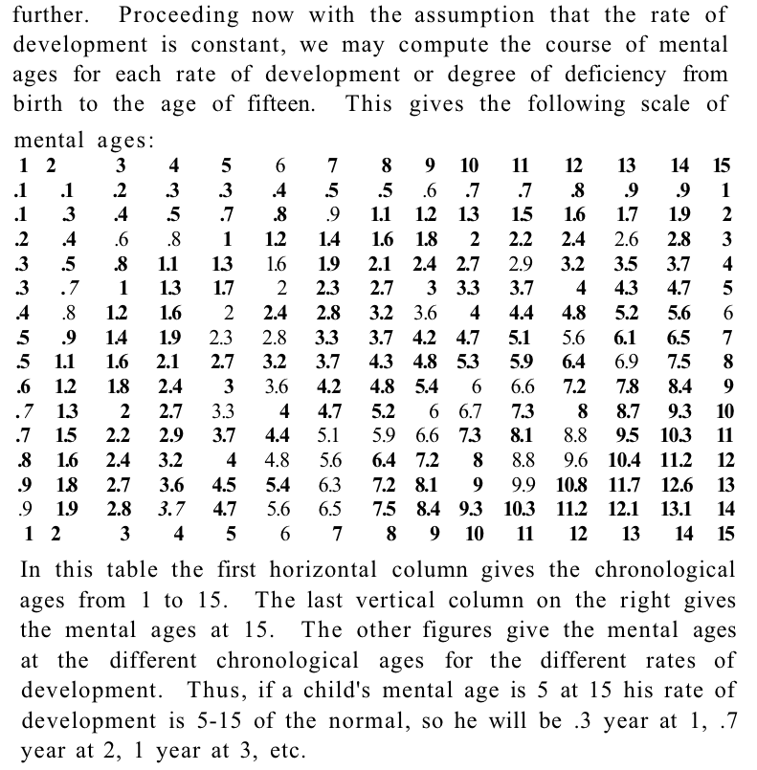

Figure 3 (continued on next page):

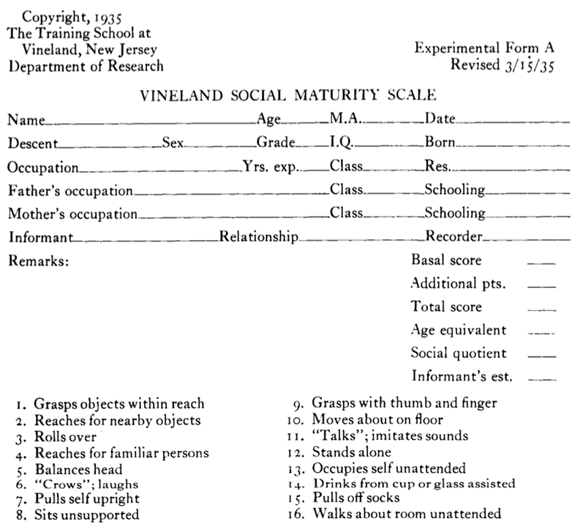

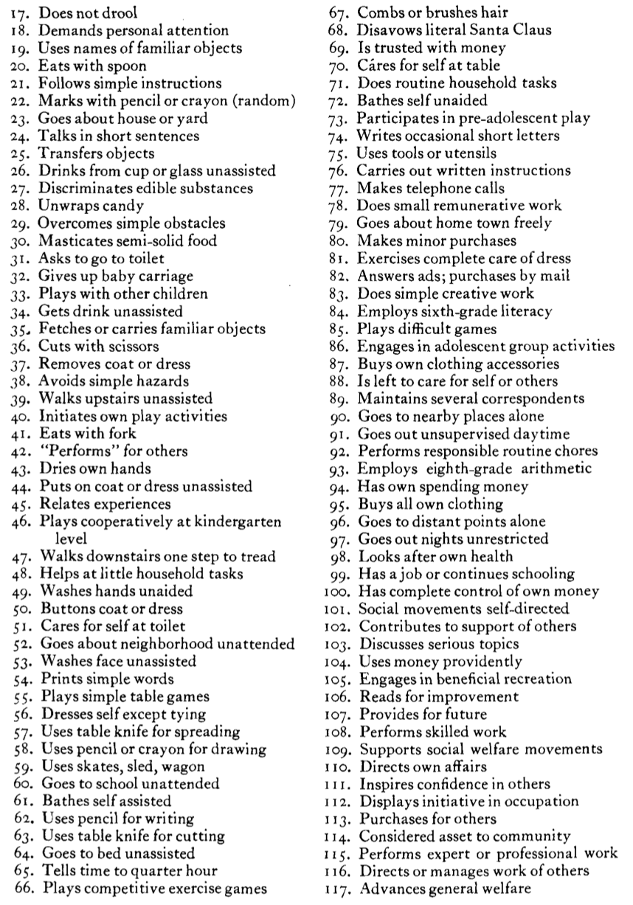Figure 3 continued:

**References**

Anderson, Margo and Stephen E. Fienberg. 1999. “To Sample or Not to Sample? The 2000 Census Controversy.” *The Journal of Interdisciplinary History* 30(1):1–36.

Armstrong, Clairette P. 1935. “Some Mental and Social Inadequates.” *Journal of Abnormal and Social Psychology* 30(3):371–83.

Bachelard, P. M. 1931. “Can We Diagnose Feeble-Mindedness in Children.” *Australasian Journal of Psychology and Philosophy* 9(2):120–30.

Bagnall, A. and G. Eyal. 2016. *Forever Children" and Autonomous Citizens: Comparing the Deinstitutionalizations of Psychiatric Patients and Developmentally Disabled Individuals in the United States*.

Bagnall, Adrianna and Gil Eyal. 2016. “‘Forever Children’ and Autonomous Citizens: Comparing the Deinstitutionalizations of Psychiatric Patients and Developmentally Disabled Individuals in the United States.” *Advances in Medical Sociology* 17:27–61.

Bannerman, Diane J., Jan B. Sheldon, James A. Sherman, and Alan E. Harchik. 1990. “Balancing the Right to Habilitation with the Right to Personal Liberties: The Rights of People with Developmental Disabilities to Eat Too Many Doughnuts and Take a Nap.” *Journal of Applied Behavior Analysis* 23(1):79–89.

Bernstein, Charles. 1920. “Colony and Extra-Institutional Care for the Feebleminded.” *Mental Hygiene* 4(1):1–28.

Bernstein, Charles. 1923. *Colony and Parole Care for Dependents and Defectives...* National Committee for Mental Hygiene, Inc.

Bernstein, Charles. 1927. “Advantages of Colony Care of Mental Defectives.” *Psychiatric Quarterly* 419–25.

Berry, Richard J. A. and R. G. Gordon. 1931. *The Mental Defective: A Problem in Social Insufficiency*. London: Kegan Paul, Trench, Trubner & Co., Ltd.

Burnham, William H. 1922. “The Normal Mind.” *Pedagogical Seminary* 29:383–99.

Carson, John. 2007. *The Measure of Merit: Talents, Intelligence, and Inequality in the French and American Republics, 1750-1940*. Princeton University Press.

Certo, Nicholas J. et al. 2008. “Seamless Transition and Long-Term Support for Individuals with Severe Intellectual Disabilities.” *Research and Practice for Persons with Severe Disabilities* 33(3):85–95.

Cline Cohen, Patricia. 1982. “A Calculating People: The Spread of Numeracy in Early America.”

Daston, Lorraine. 1992. “Objectivity and the Escape from Perspective.” *Social Studies of Science* 22(4):597–618.

David, Henry P., John D. Smith, and Erwin Friedman. 1976. “Family Planning Services for Persons Handicapped by Mental Retardation.” *American Journal of Public Health* 66(11):1053–57.

Desrosières, Alain. 1998. “The Politics of Large Numbers: A History of Statistical Reasoning, Trans.” *Camille Naish (Cambridge, MA, 1998)*.

Didier, Emmanuel. 2002. “Sampling and Democracy: Representativeness in the First United States Surveys.” *Science in Context* 15(3):427–45.

Doll, Edgar A. 1919. “The Average Mental Age of Adults.” *Journal of Applied Psychology* 3(4):317–28.

Doll, Edgar A. 1923. “New Thoughts about the Feeble-Minded.” *The Journal of Educational Research* 8(1):31–48.

Doll, Edgar A. 1935. “The Genetic Scale of Social Maturity.” *The American Journal of Orthopsychiatry* 5(2):180–90.

Doll, Edgar A. 1940a. “Family Care of Mental Defectives.” *Journal of Consulting Psychology* 15–16.

Doll, Edgar A. 1940b. “The Nature of Mental Deficiency.” *Psychological Review* 47(5):395–415.

Doll, Edgar A. 1940c. “The Social Basis of Mental Diagnosis.” *Journal of Applied Psychology* 24(2):160.

Doll, Edgar A. 1947. “Is Mental Deficiency Curable?” *American Journal of Mental Deficiency* 51(3):420–28.

Doll, Edgar A. 1948. “What Is a Moron?” *The Journal of Abnormal and Social Psychology* 43(4):495–501.

Drinkwater, Chris. 2015. “Supported Living and the Production of Individuals.” Pp. 229–44 in *Foucault and the Government of Disability*, edited by Tremain. Ann Arbor: University of Michigan Press.

Dubrow, Max. 1960. “Sheltered Workshops for the Mentally Retarded as an Educational and Vocational Experience.” *The Personnel and Guidance Journal* 38(5):392–95.

Dybwad, Gunnar. 1996. “From Feeblemindedness to Self-Advocacy: A Half Century of Growth and Self-Fulfillment.” *European Journal of Mental Disability* 3(11):3–18.

Espeland, Wendy Nelson and Michael Sauder. 2012. “The Dynamism of Indicators.” *Governance by Indicators Global Power through Classification and Rankings* 86–109.

Espeland, Wendy Nelson and Mitchell Stevens. 2008. “A Sociology of Quantification.” *European Journal of Sociology* 49(3):401–36.

Espeland, Wendy Nelson and Berit Irene Vannebo. 2007. “Accountability, Quantification, and Law.” *Annu. Rev. Law Soc. Sci.* 3:21–43.

Eyal, Gil, Brendan Hart, Emine Onculer, Neta Oren, and Natasha Rossi. 2010. *The Autism Matrix: The Social Origins of the Autism Epidemic*. Malden, MA: Polity Press.

Findlay, Leonard. 1935. “The Nature of Mental Deficiency.” *Post-Graduate Medical Journal* 11(115):182–86.

Foucault, Michel. 1975. *Discipline and Punish: The Birth of the Prison*. New York: Vintage Books.

Foucault, Michel. 2003. *Abnormal: Lectures at the Collège de France, 1974-1975*. New York City: Picador.

Friedman, Erwin. 1971. “Missing in the Life of the Retarded Individual--Sex: Reflections on Sol Gordon’s Paper.” *Journal of Special Education* 5(4):365–68.

Gesell, Arnold. 1940. “The Stability of Mental Growth Careers.” Pp. 149–60 in *The thirty-ninth yearbook of the National Society for the Study of Education: Intelligence: Its nature and nurture, Part II, Original studies and experiments*, edited by G. M. Whipple. Bloomington, IL: Public School Publishing Co.

Hacking, Ian. 1999. “Making Up People.” Pp. 161–71 in *Reconstructing Individualism*, edited by T. L. Heller, M. Sosna, and D. E. Wellberry. Stanford, CA: Stanford University Press.

Heimer, Carol. 1985. “Reactive Risk and Relative Risk: Managing Moral Hazard in Insurance Contracts.”

Herbst, Susan. 1993. *Numbered Voices: How Opinion Polling Has Shaped American Politics*. University of Chicago Press.

Igo, Sarah Elizabeth. 2007. *The Averaged American: Surveys, Citizens, and the Making of a Mass Public*. Harvard University Press.

Kamin, Leon J. 1974. *The Science and Politics of IQ*. New York: Routledge.

Katz, Michael B. 1986. “In the Shadow of the Poorhouse.” *A Social History of Welfare in America* 14.

Koegel, Paul. 1986. “You Are What You Drink: Evidence of Socialized Incompetence in the Life of a Mildly Retarded Adult.” Pp. 47–63 in *Culture and Retardation*. Springer.

Kuhlmann, Fred. 1913. “Degree of Mental Deficiency in Children as Expressed by the Relation of Age to Mental Age.” *Journal of Psycho-Asthenics* 17:132–44.

Lamont, Michèle and Virág Molnár. 2002. “The Study of Boundaries in the Social Sciences.” *Annual Review of Sociology* 28(1):167–95.

Latour, Bruno. 1987. *Science in Action: How to Follow Scientists and Engineers through Society*. Harvard university press.

Levinson, Jack. 2010. *Making Life Work: Freedom and Disability in a Community Group Home*. Minneapolis: University of Minnesota Press.

Miller, Peter and Nikolas Rose. 1990. “Governing Economic Life.” *Economy and Society* 19(1):1–31.

Nirje, Bengt. 1972. “The Right to Self-Determination.” Pp. 176–200 in *Normalization: The principle of normalization*, edited by W. Wolfensberger. Toronto: National Institute on Mental Retardation.

O’Brien, John. 1994. “Down Stairs That Are Never Your Own: Supporting People with Developmental Disabilities in Their Own Homes.” *Mental Retardation* 32(1):1–6.

Parnicky, Joseph J. and Leonard N. Brown. 1964. “Introducing Institutionalized Retardates to the Community.” *Social Work* 9(1):79–85.

Porter, Theodore. 1995. “Trust in Numbers. The Search for Objectivity in Science and Public Life.” *Trust in Numbers: The Search for Objectivity in Science and Public Life*.

Power, Michael. 1997. *The Audit Society: Rituals of Verification*. OUP Oxford.

Ranson, Stewart. 2003. “Public Accountability in the Age of Neo‐liberal Governance.” *J. Education Policy* 18(5):459–80.

Rothman, David J. 1980. *Conscience and Convenience: The Asylum and Its Alternatives in Progressive America*. Revised Ed. New York: Aldine Transaction.

Rusnock, Andrea A. 2002. *Vital Accounts: Quantifying Health and Population in Eighteenth-Century England and France*. Cambridge University Press.

Scott, James C. 1998. *Seeing like a State: How Certain Schemes to Improve the Human Condition Have Failed*. Yale University Press.

Tizard, Jack. 1950. “The Abilities of Adolescent and Adult High-Grade Male Defectives.” *The British Journal of Psychiatry* 96(405):889–907.

Tobias, Jack. 1960. “Evaluation of Vocational Potential of Mentally Retarded Young Adults.” *Training School Bulletin* 56(4):122–35.

Tredgold, Alfred Frank. 1908. *A Textbook of Mental Deficiency*. Baltimore: The Williams and Wilkins Company.

Tredgold, Alfred Frank. 1928. “The Nature of Mental Deficiency.” *Post-Graduate Medical Journal* 3(32):133–37.

Tremain, Shelley Lynn. 2005. *Foucault and the Government of Disability*. Ann Arbor: University of Michigan Press.

Trent, James W. 1994. *Inventing the Feeble Mind: A History of Mental Retardation in the United States*. Univ of California Press.

Wallace, G. L. 1929. “Are the Feebleminded Criminals.” *Mental Hygiene* 13(1):93–98.

Wallin, J. E.Wallace. 1916. “Who Is Feebleminded?” *Journal of the American Institute of Criminal Law and Criminology* 706–16.

Wolfensberger, Wolf. 1967. “Vocational Preparation and Occupation.” *Mental Retardation. Chicago: Aldine* 232–73.

1. For example, see *The Good Doctor* and *Atypical*. These television shows have received mixed reviews. See for example: <https://www.nytimes.com/2017/11/12/arts/television/the-good-doctor-freddie-highmore-abc.html>, <https://www.pastemagazine.com/articles/2017/09/the-good-doctor-review-freddie-highmore-abc-house.html>, and <https://www.theatlantic.com/entertainment/archive/2017/08/atypical-review-netflix/536538/>
2. See <https://www.nytimes.com/2016/11/20/health/autism-spectrum-college.html>, <https://www.nytimes.com/2015/09/06/opinion/sunday/adult-autistic-and-ignored.html>, <https://www.washingtonpost.com/local/woman-with-down-syndrome-prevails-over-parents-in-guardianship-case/2013/08/02/4aec4692-fae3-11e2-9bde-7ddaa186b751_story.html?utm_term=.7eca42ebfdfe>, and https://www.washingtonpost.com/local/why-a-man-with-intellectual-disabilities-has-fewer-rights-than-a-convicted-felon/2015/09/21/2281f5c0-605e-11e5-b38e-06883aacba64_story.html?utm_term=.949297b7e1bb
3. The AAIDD has gone through a number of name changes throughout the years, all corresponding with the terminology of the time. 1906: American Association for the Study of the Feebleminded; 1933: American Association on Mental Deficiency; 1987: American Association on Mental Retardation; 2007: American Association on Intellectual and Developmental Disabilities. In this paper, I will use feebleminded, mental deficiency, mental retardation, and intellectual and developmental disability, as appropriate to the time frame, to refer to the same collection of disabilities
4. First published in 1896 under the name *Journal of Psycho-Aesthenics*. The name was later changed to the *American Journal of Mental Deficiency*, and then the *American Journal of Mental Retardation* in keeping with the name changes of the organization.
5. For an overview please see figure 1
6. The image of the eternal child has been attributed to parent accounts of raising a child with Mental Retardation in the 1950s and 60s (Adrianna Bagnall and Eyal 2016; Eyal et al. 2010; Trent 1994). This image was criticized by advocates in the 1970s and 80s during the movement toward deinstitutionalization because it inhibited the extension of civil rights to the mentally retarded (Dybwad 1996).
7. See figure 2